Year 11 Film Techniques
“Film techniques” is the term used to describe the ways that meaning is created in film.
In Film Exams, “film techniques” are often termed “Visual and Verbal techniques/features” OR “Language techniques/features.”
* Every film essay must refer to a range of the following techniques as examples:
Visual Techniques: Verbal Techniques:
* Acting/body language * Dialogue (Screenplay)
* Camera shots and angles * Music
* Lighting * Sound (Diegetic: At the time of filming)
* Costume (Non-diegetic: Added later)
* Props * Voice over
* Set design
* Special Effects
* Colour
* Editing

Camera Shots
A camera shot is the amount of space that is seen in one shot or frame. Camera shots are used to demonstrate different aspects of a film's setting, characters and themes. As a result, camera shots are very important in shaping meaning in a film.
An extreme long shot contains a large amount of landscape. It is often used at the beginning of a scene or a film to establish general location (setting). This is also known as an establishing shot.
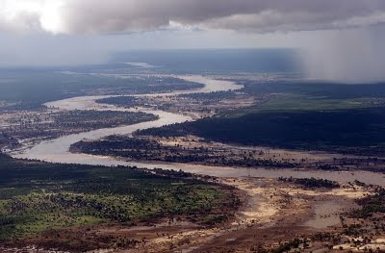
A long shot contains landscape but gives the viewer a more specific idea of setting. A long shot may show the viewers the building where the action will take place.
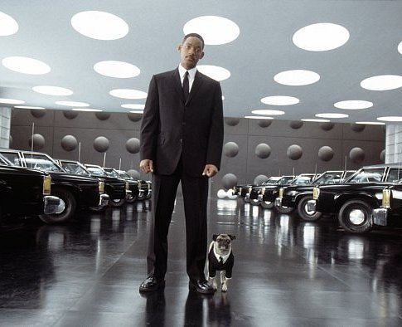
A full shot contains a complete view of the characters. From this shot, viewers can take in the costumes of characters and may also help to demonstrate the relationships between characters.
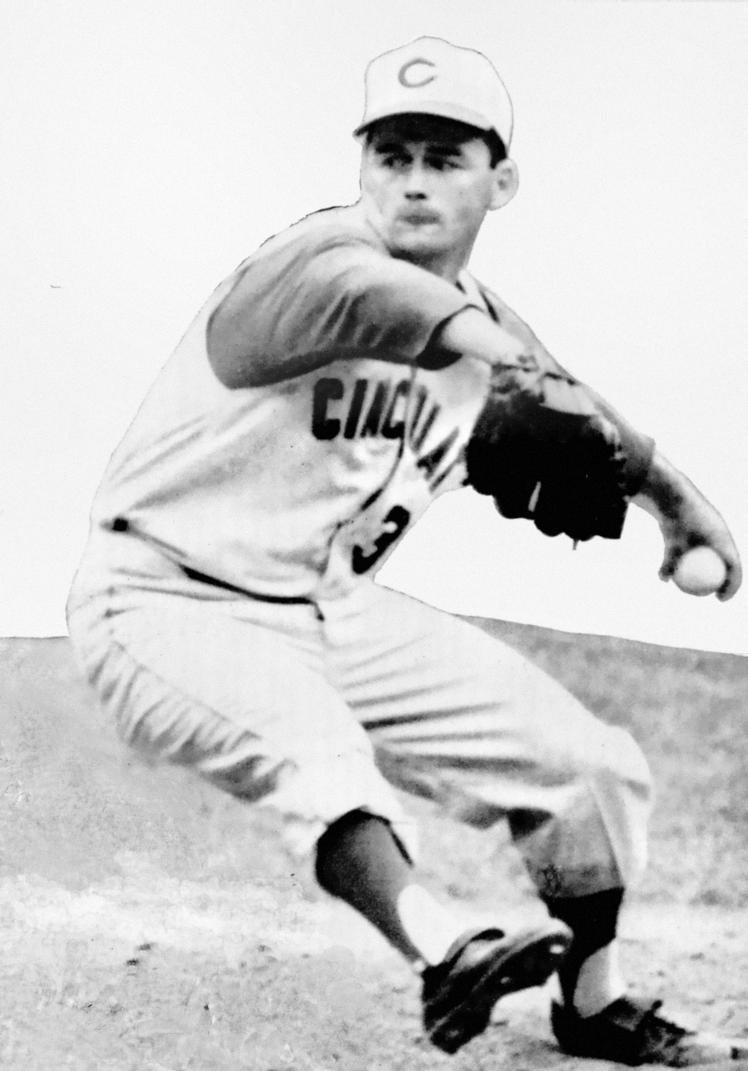
A mid shot contains the characters or a character from the waist up. From this shot, viewers can see the characters' faces more clearly as well as their interaction with other characters. This is also known as a social shot.
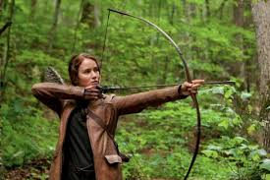
A close-up contains just one character's face. This enables viewers to understand the actor's emotions and also allows them to feel empathy for the character. This is also known as a personal shot.
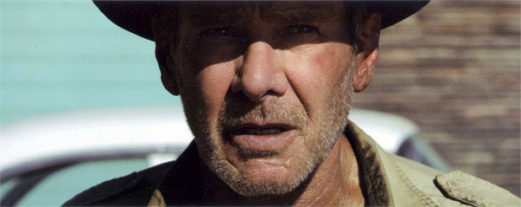
An extreme close-up contains one part of a character's face or other object. This technique is quite common in horror films, particularly the example below. This type of shot creates an intense mood and provides interaction between the audience and the viewer.
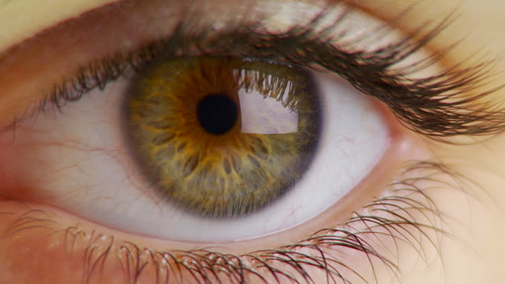
When analysing a film you should always think about the different camera shots and why they are being used.

Camera angles
It is important that you do not confuse camera angles and camera shots. Camera shots are used to demonstrate different aspects of setting, themes and characters. Camera angles are used to position the viewer so that they can understand the relationships between the characters. These are very important for shaping meaning in film as well as in other visual texts.
The following examples will help you to understand the differences between the different camera angles
A bird's eye angle is an angle that looks directly down upon a scene. This angle is often used as an establishing angle, along with an extreme long shot, to establish setting.
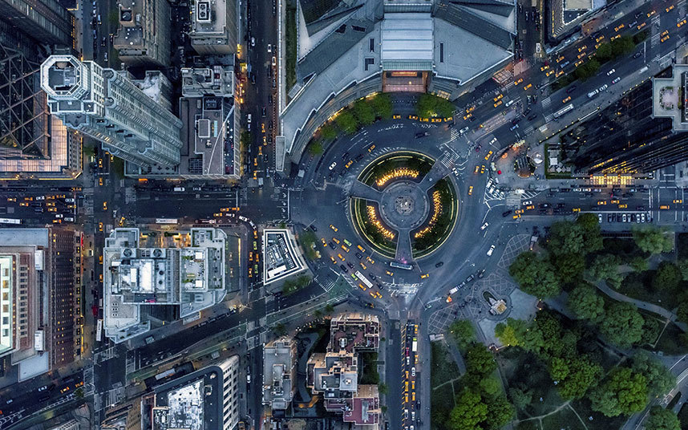
A high angle is a camera angle that looks down upon a subject. A character shot with a high angle will look vulnerable or small. These angles are often used to demonstrate to the audience a perspective of a particular character. The example below demonstrates to us the perspective or point of view of Frodo Baggins. As a viewer we can understand that the hobbit feels vulnerable.
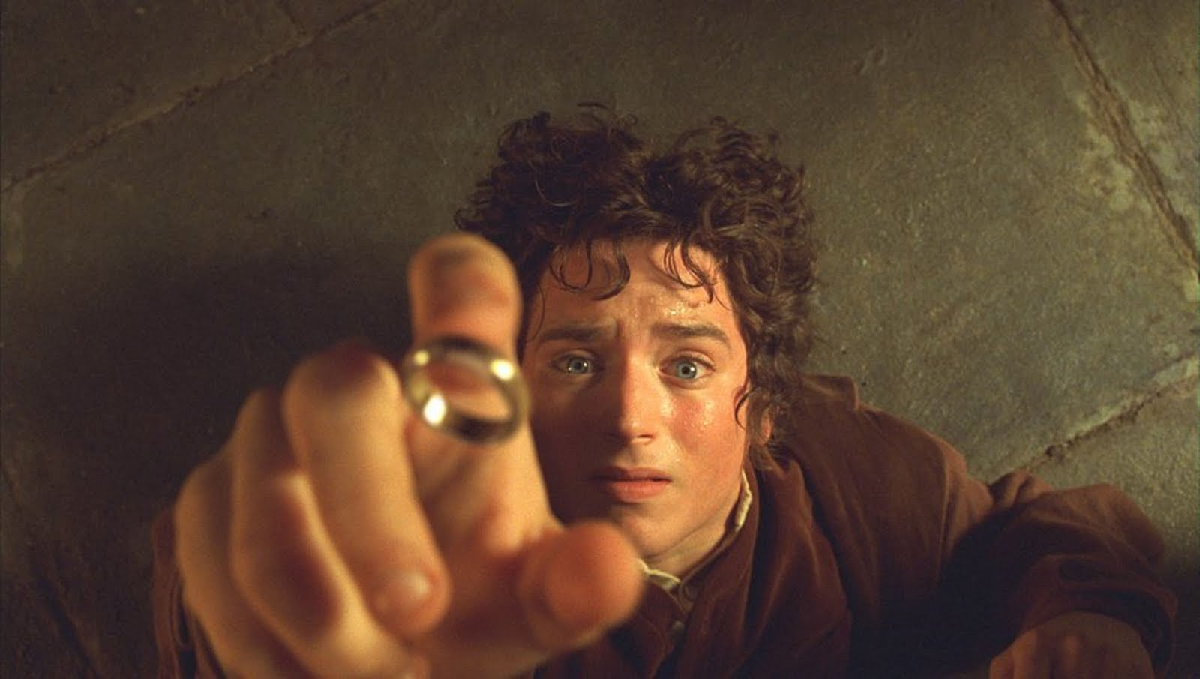

An eye-level angle puts the audience on an equal footing with the character/s. This is the most commonly used angle in most films as it allows the viewers to feel comfortable with the characters.
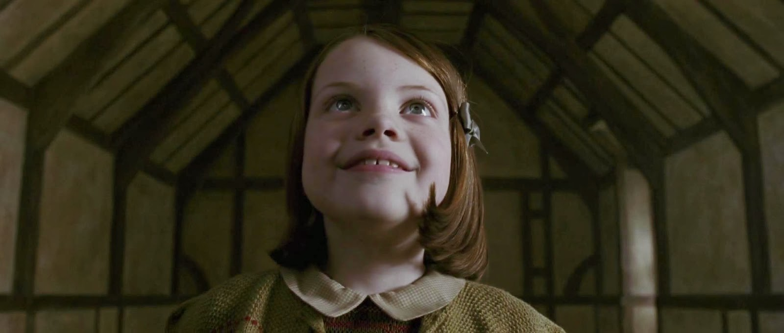
A low angle is a camera angle that looks up at a character. This is the opposite of a high angle and makes a character look more powerful. This can make the audience feel vulnerable and small by looking up at the character. This can help the responder feel empathy if they are viewing the frame from another character's point of view.
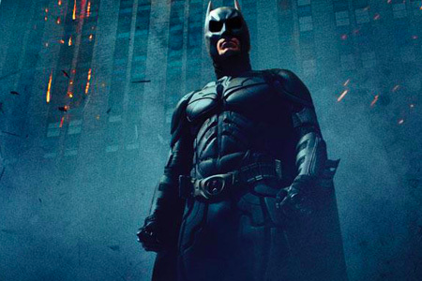
A Dutch angle is used to demonstrate the confusion of a character. The example below should disorientate you.
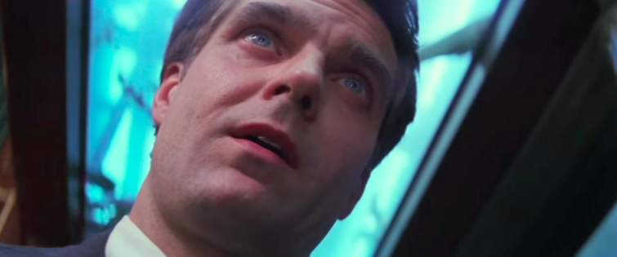

Camera movement
Composers of films also use camera movement to shape meaning. The following are some examples of common camera movements and how they can be used to shape meaning in films.
A crane shot is often used by composers of films to signify the end of a film or scene. The effect is achieved by the camera being put on a crane that can move upwards.
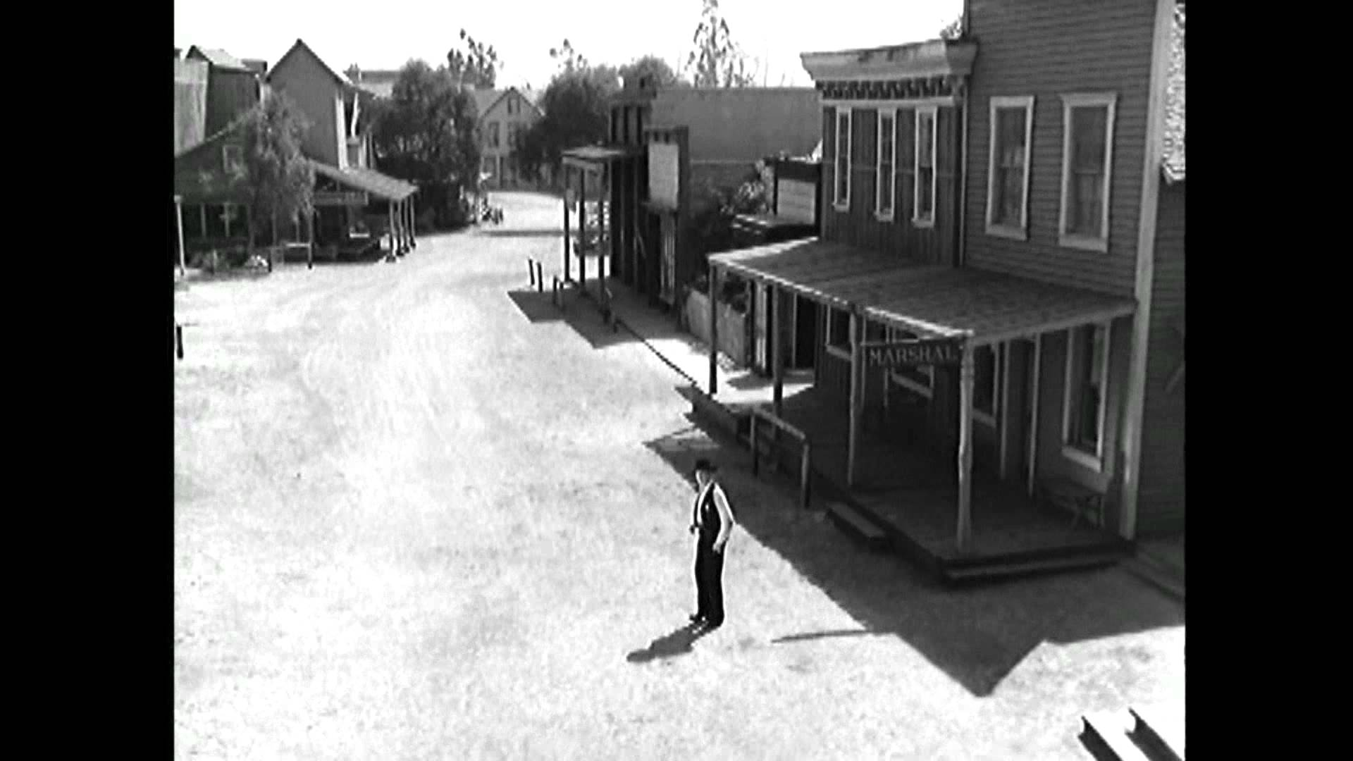
A tracking shot and a dolly shot have the same effect. A tracking shot moves on tracks and a dolly shot is mounted on a trolley to achieve the effect in the example below. This camera movement is used in a number of ways but is most commonly used to explore a room such as a restaurant. By using a tracking shot or a dolly shot the composer of a film gives the viewer a detailed tour of a situation. It can also be used to follow a character.
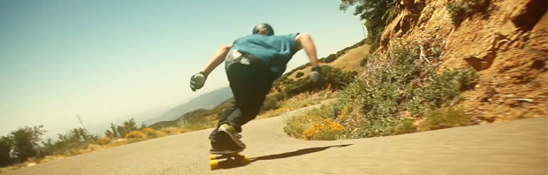
Panning is used to give the viewer a panoramic view of a set or setting. This can be used to establish a scene.
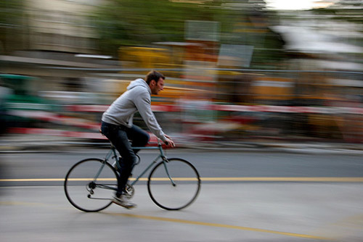

Lighting
Lighting is a very important aspect for shaping meaning in films. What kind of atmosphere is created in a room lit by candles? Have you ever heard of mood lighting? A room that is brightly lit by neon lights might seem to be sterile or a shadowy room might be eerie or scary. The lighting technicians in a film crew have the task of creating lighting to suit the mood and atmosphere of each scene in a film.
Two main types of lighting:
Natural lighting- caused by the sun
Artificial lighting- caused by electricity
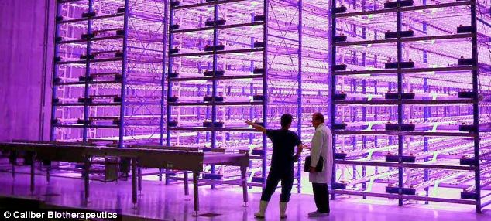

Cinematography
Cinematography is the combination of the techniques described in these notes. This includes camera shots, camera angles, camera movement and lighting. Use the term cinematography to group all of these together, for example, 'The cinematography in that film was exceptional.'

Mise en Scene
Mise en scene refers to all the objects and characters in a particular frame. More specifically, it refers to the composition of the frame. When you use the term “mise en scene,” you are discussing where the composer or director has placed all the elements of the scene within the frame.
Sounds
Diegetic sound is any sound presented as originating from a source within the film's world.

Non-diegetic sound is any sound that obviously does not originate from a source within the film's world. (I.e. It is added later to the film for a special “effect.”)

